Task08.Run staic code analysis

8.Run static code analysis.png

server.py

8_server_modified.png

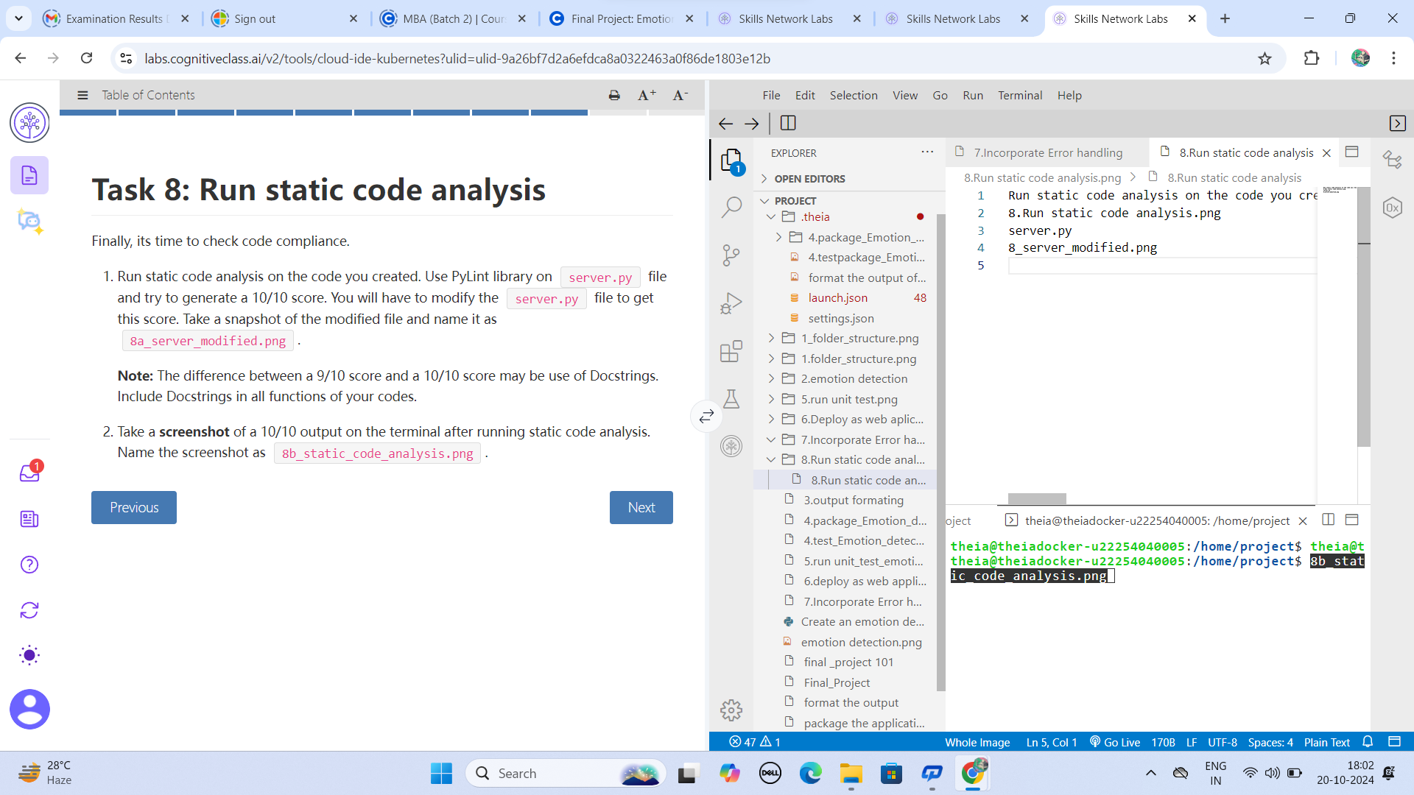

**Conclusion:**

**completing the project.**

1. Created an Emotion Detection application using the functions from embeddable AI libraries
2. Extracted relevant information from the output received from the function
3. Tested and packaged the application created using the Emotion Detection function
4. Completed web deployment of your application using Flask
5. Incorporated error handling in your application to account for invalid input to your application
6. Written codes that are in perfect compliance with PEP8 guidelines, getting 10/10 score in static code analysis